1. **SQL** (Structured Query Language) is a programming language dedicated to manage the data in relational databases; **DML** (Data Manipulation Language) is a part of SQL dedicated to operate with the data in relational database. It implements CRUD operations – Create, Read, Update and Delete; **DDL** (Data Definition Language) is part of SQL dedicated to operate with database structure – tables, permissions and so on.
2. **T-SQL** (Transact SQL) is a Microsoft proprietary language extending the SQL language. It adds procedural programming, variables, functions and so on to SQL.
3. Here is database screenshot:

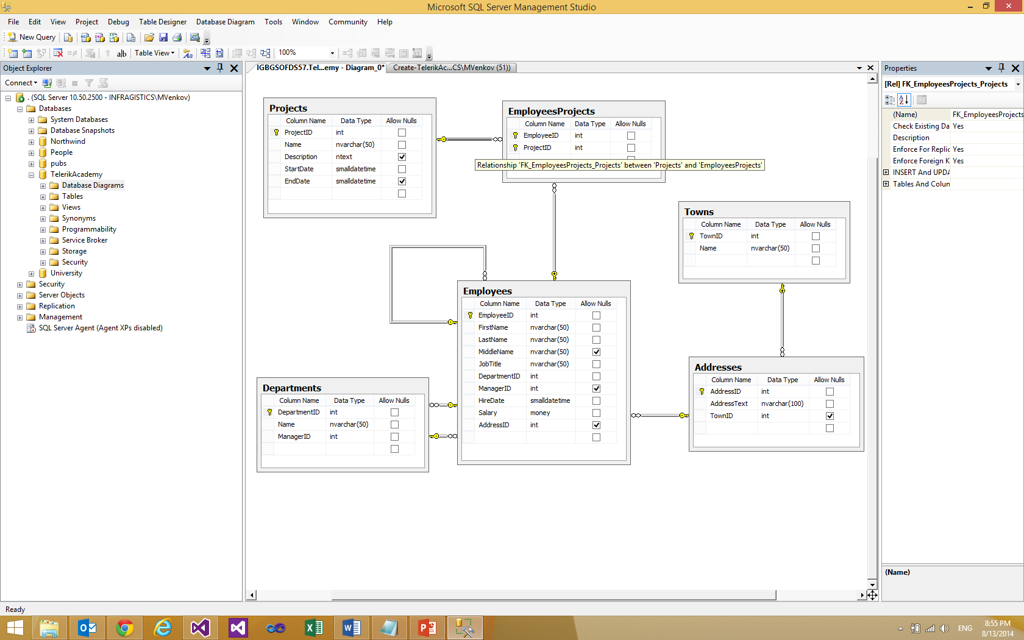

1. SELECT * FROM Departments
2. SELECT d.Name FROM Departments AS d
3. SELECT e.Salary FROM Employees As e
4. SELECT e.FirstName + ' ' + e.LastName AS [Full Name] FROM Employees As e
5. SELECT e.FirstName + '.' + e.LastName + '@telerik.com '

AS [Full Email Addresses]

FROM Employees As e

1. SELECT DISTINCT e.Salary FROM Employees As e
2. SELECT * FROM Employees As e

WHERE e.JobTitle = 'Sales Representative'

1. SELECT e.FirstName FROM Employees As e

WHERE e.FirstName LIKE 'Sa%'

1. SELECT e.LastName FROM Employees As e

WHERE e.LastName LIKE '%ei%'

1. SELECT e.LastName ,e.Salary FROM Employees As e

WHERE e.Salary BETWEEN 20000 AND 30000

1. SELECT e.LastName ,e.Salary FROM Employees As e

WHERE e.Salary IN(25000,14000,12500,23600)

1. SELECT e.FirstName + ' ' + e.LastName + ' is boss'

AS [All the managers]

FROM Employees As e

WHERE e.ManagerId IS NULL

1. SELECT e.FirstName + ' ' + e.LastName

AS [Full name], e.Salary

FROM Employees As e

WHERE e.Salary > 50000

ORDER BY e.Salary DESC

1. SELECT TOP 5 e.FirstName + ' ' + e.LastName

AS [Full name], e.Salary

FROM Employees As e

ORDER BY e.Salary DESC

1. SELECT e.FirstName + ' ' + e.LastName AS [Full name],

a.AddressText

FROM Employees As e

INNER JOIN Addresses as a

ON e.AddressID = a.AddressID

1. SELECT e.FirstName + ' ' + e.LastName AS [Full name],

a.AddressText

FROM Employees As e, Addresses as a

WHERE e.AddressID = a.AddressID

1. SELECT e.FirstName + ' ' + e.LastName AS [Full name],

m.FirstName + ' ' + m.LastName AS [Manager Full Name]

FROM Employees As e

INNER JOIN Employees AS m

ON e.ManagerID = m.EmployeeID

1. SELECT e.FirstName + ' ' + e.LastName AS [Full name],

m.FirstName + ' ' + m.LastName AS [Manager Full Name],

a.AddressText

FROM Employees As e

INNER JOIN Employees AS m

ON e.ManagerID = m.EmployeeID

INNER JOIN Addresses AS a

ON e.AddressID = a.AddressID

1. SELECT d.Name

FROM Departments AS d

UNION

SELECT t.Name

FROM Towns AS t

1. SELECT e.FirstName + ' ' + e.LastName AS [Employee name],

m.FirstName + ' ' + m.LastName AS [Manager name]

FROM Employees AS e

LEFT JOIN

Employees AS m

ON e.ManagerID = m.EmployeeID

SELECT e.FirstName + ' ' + e.LastName AS [Employee name],

m.FirstName + ' ' + m.LastName AS [Manager name]

FROM Employees AS m

RIGHT JOIN

Employees AS e

ON e.ManagerID = m.EmployeeID

1. SELECT e.FirstName + ' ' + e.LastName AS [Employee name],

d.Name AS [Department name],

e.HireDate AS [Year hired]

FROM Employees AS e

INNER JOIN

Departments AS d

ON e.DepartmentID = d.DepartmentID

WHERE e.HireDate BETWEEN '1995-01-01' AND ' 2005-01-01'

ORDER BY e.HireDate